Seminar Paper Group 9

MBF Practitioner Seminar

Impact of fundamental research on investing in Asia –

Do equity funds in Asia outperform indices and if so, why?

By Anandita Kuthiala, Ruonan Qu, Shuwen Sun, Tobias Wiest

Date: 09.02.2019

Advisors:

Simon Strautmann – University of St. Gallen

Annette Watzke – Fidelity International

Albrecht von Bassewiz – Fidelity International

**List of Contents**

1. Introduction 2

2. Literature Overview 2

3. Data 2

4. Methodology 2

5. Results 2

6. Conclusion 2

Appendix 2

**1. Introduction**

According to the Investment Company Institute (ICI 2018), the total net assets of regulated open-end funds added up to $46.7 trillion at the end of 2018. The largest share of that number with $19.9. trillion fell under the umbrella of equity funds. The biggest market for mutual funds has historically been the US Mutual Funds market and it still is with total net assets of $17.7 trillion in 2018, 52% of which fall under the umbrella of equities. The ICI calculated the annual asset-weighted average expense ratio for these US equity mutual funds to be 0.55%. Considering these numbers, one notices that mutual fund managers earn substantial revenue for their mandate to invest on their clients’ behalf. For this reason, investors and researchers around the world have questioned for decades whether active mutual fund managers have superior skill and knowledge that results in gross returns that are higher than those of passive benchmarks such as index funds in a manner so that their higher charges are at the very least offset. Research on this topic has historically shown mixed results, but results show negative performance alphas of mutual funds more often than positive ones. Sharpe (1966), Jensen (1968), Elton et al. (1993) and Carhart (1997) are among many famous publication that find overall worse performance of mutual fund performance after fees versus a passive index benchmark. Today, the S&P DJI publishes the “S&P INDICES VERSIS ACTIVE” (SPIVA) Scorecards to inform investors whether to invest in active funds or passive ETF alternatives. The SPIVA Scorecards show semi-annually how many percent of funds outperform their appropriate benchmark. Consistent with most of the academic research, the most recent SPIVA for June 2019 indicates that around 70% of actively managed US large cap funds underperformed the S&P 500. This number gets worse for the active mutual fund managers for longer time horizons, indicating that those funds that do not underperform in one period do not have persistent skill to repeat this achievement over the next years. While SPIVA covers many regions and countries, China and other emerging markets in Asia (except India) are not included. This seminar paper sheds light on the performance of the mutual funds invested in those areas. The study examines all open-end funds listed in Morningstar under the global category “Equity” and the investment areas China, India, Asia Pacific ex Japan, Asia Pacific ex Japan ex Australia, and Asia Emerging Markets. First, we use the CAPM model, the three and five factor model of Fama and French and the Carhart four factor model to get investment region-wide monthly alphas over all funds in the respective region. For most regions, alphas are very heterogenous depending of the benchmark used and the factor model used. We discuss these differences for each region but go into more detail for the region China.

In contrast to other regions, Chinese funds outperform every benchmark in every factor setting. Also, the funds achieve higher average alphas against the CSI300 than against the MSCI China. We examine where this outperformance is coming from and take both stock characteristics and fund characteristics into consideration. To do this, we extract the fund specific alphas that arose from the four-factor model regression against the CSI300 over the last three years.

For the fund characteristics, we regress these alphas against fund size, their latest expense ratio and the funds age. Also, we split the funds into deciles and calculate the average fund size, expense ratio and age for each decile. Both the regression results and the decile averages indicate that bigger, younger and less expensive funds outperform the CSI300 by a higher margin than their peers.

For the equity characteristics we download the holding data of 13 funds from Thomson Reuters over the last 12 quarters, which were represented in either top or low alpha decile. Using the weights of the fund holdings, we calculate the average institutional ownership of the stocks held, the average number of stock analysts recommending the stocks held and average holdings in state-owned enterprises. Overall, we find that the top performing funds hold less state-owned enterprises and stocks with higher institutional ownership. We repeat this procedure for the two benchmarks MSCI China and the CSI 300. The higher outperformance of the funds against the CSI 300 compared to the MSCI China can partly be explained by a lower percentage of state-owned constituents in the MCSI China compared to the CSI 300.

The rest of this seminar paper is structured as follows. In chapter two, we present literature which introduced the performance measures used in our study and publications that deal with topics like ours. The third chapter sheds light on the fund sample selection and on the benchmarks used in our study. After a short introduction to our methodology, we present the main findings of this work. Finally, we conclude this work by summarizing and by pointing out implications for investors and for future academic work.

**2. Literature Overview**

**3. Data**

For the empirical study, data on a wide range of equity funds was downloaded from Morningstar Direct. The sample was filtered out by a small set of limitations in the search query. Because this paper examines equity funds only, each fund in our dataset must be in the Morningstar Global Broad Category "Equity”. To ensure a balanced range of different investment regions on the Asian continent, we select funds that are included in either of Morningstar's investment areas "Asia Pac ex Japan", "Asia Pac ex Japan ex Australia", "China", "India" and "Asia Emerging Mkts". Funds listed as "Asia Pac ex Japan ex Australia” or "Asia Pac ex Japan" are combined into one category for further analysis. Further, because our study aims to answer the question whether active mutual fund managers can outperform their benchmarks, we exclude all the funds that are not actively managed, namely all funds which are listed as index funds in Morningstar. To avoid survivorship bias, we include non-surviving funds. The raw Morningstar data set was then transformed into a long format so that each row is assigned a monthly observation of one fund. In total, this dataset reports returns, fund size and the Morningstar “equity style factor” of 2851 funds over 120 months. Because not every fund existed over the full period of ten years from 01.01.2019 – 31.12.2019 and, because for some funds data was not available for all months, the finished dataset includes a total of 186,420 rows.

Table 1: Basic properties of the fund sample data

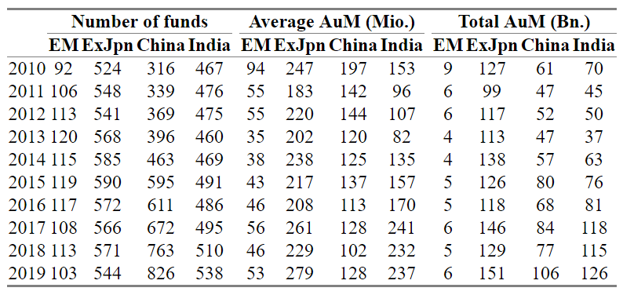

Table 1 illustrates the most important descriptive statistics in the panel set. All columns were calculated using datapoints reported at the end of December each year. Overall, one can see that both the number of funds and the overall money invested in our investment regions increased substantially over the last decade, with one exception being the funds classified as Asia emerging markets funds, whose average size and total assets under management decreased. The Chinese investment area saw the biggest increase in the number of funds and total assets with +161% and +74% respectively. The monthly total returns provided by Morningstar determined each month by dividing the change in net asset value, reinvesting all income and capital-gains distributions during the month, and dividing by the starting NAV (Morningstar 2018). Both the fund size, which includes the money invested across all the funds’ share classes, and the returns were downloaded in Euro. Monthly returns of the different benchmarks used in the factor models were also downloaded from Morningstar.

For the factor returns we use the data provided by Fama and French which are calculated with stock returns from all public companies in countries defined as emerging markets. Although this universe also includes non-Asian emerging markets, we consider the factor returns appropriate for our study. This is because the Asian emerging markets and China specifically represent a large weight in this universe. All factor returns were currency-adjusted to Euro.

Quarterly stock holdings data of Chinese funds, who achieved alphas either in the highest or lowest decile of Carhart 4-factor alphas against the CSI300 over the last three years, was downloaded from the Thomson Reuter’s Eikon database. Funds for which not at least semi-annual holding data was available were excluded, leaving only 13 funds. Additionally, the quarterly constituent weights for the MSCI China and the CSI300 were obtained in Eikon. For the 1251 stocks that were held either by the funds or the benchmarks over the last three years, information was taken from Bloomberg on the number of analyst recommendations, the percentage of institutional ownership and whether the company is a state-owned enterprise.

**4. Methodology**

**5. Results**

**6. Conclusion**

**Appendix**